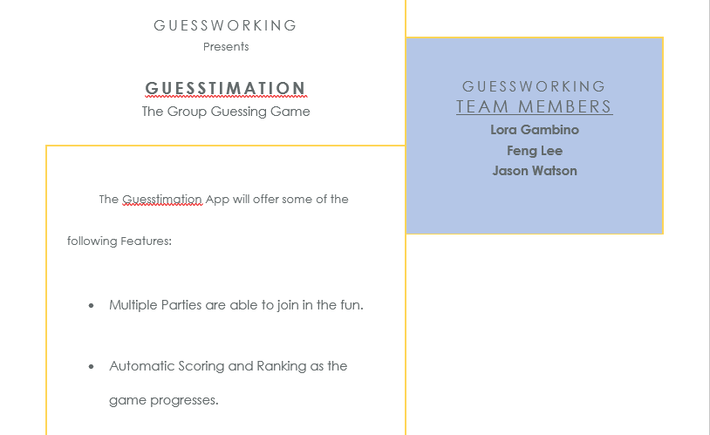 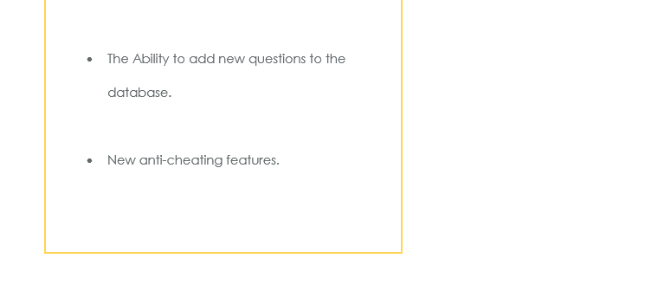

**Problem Definition:**

The existing Guesstimation game is setup and run through Excel and is slow and buggy; cheating has been claimed by some fellow participants in the past. So a new Guesstimation application has been commissioned to be created! This will be an Android application which would allow parties to guess their answer and submitting it back to the facilitator. Our team will take over the development and will turn into a finished, working application.

**Identification of specific problems:**

Loading up the previous version, making sure we know what is working, not working, and what we can salvage so we can Integrating new designs to the previous version. Another problem would be if we want all players to see everyone’s score or just their own score.

**Estimate of the scope of project:**

Our scope for the project would be to meet our deadline of our work breakdown structure. We want to make sure we meet our current goals before going to the next phase of our project. Before we start on our project we want to get the Systems Analysis and design, and Planning documentation done, then well continue to our next step which building or fix the database back-end development. After that we would want to develop the front-end of the app and make sure everything works and is compatible with our database. When all that is finish we want to launch the application and our deadline is December 4, 2017. A few goals we also want to implement would be locking players out when they try to hop out the game to try and cheat, limit who wants to be in the group, and adding the player’s own question instead of using preset questions.

**Description of development methodology:**

Our methodology is going to be agile and our method of communication and convening is google hang outs with gethub.com. Some of our major documentation are going to be our scope statement, charter, work breakdown structure, a performance report after every deadline, and other charts such as ERD diagram and our code. The platform we use are android studio.

**Estimate of the feasibility of the project:**

The Database back-end development has been given 20 days to review, analyze, and develop the current Guesstimation application. We will be reviewing the existing structure to the application’s need and function; adding and modifying where needed.

The Development of Web forms interactive with the database will take 28 days to complete. We will be developing the interface for the Guesstimation, using previous artifacts, where able.

We will be using the last 5 days in getting the final application, camera-ready, and producing the documentation.

**Introduce your team:**

Feng Lee is 25 years old and graduated with his Associate and now he is pursuing his bachelor in MIS at Oklahoma State University. He is currently a department manager at Walmart in Claremore and looking for a Help desk job or entry level in information technology.

Jason Watson has 17 years telecommunication experience (14 yrs U.S. Cellular, 3 yrs Verizon). Working for as a Senior Analyst in Wholesale Wireless Revenue Assurance, currently in the Projects group. He is working towards a MIS degree and will be graduating in Spring 2018.

Lora Gambino has previously worked with the Tulsa Performing Arts company as a seamstress. Lora is currently involved with the “Oklahoma Women in Technology” organization. Lora is pursuing her bachelor in MIS.

**Schedule/Plan:**

**WBS**

|  |  |  |  |
| --- | --- | --- | --- |
| Task Name | Duration | Start | Finish |
| Systems Analysis and Design, and Planning Documentation. | 6 days | Wed 9/13/17 | Wed 9/20/17 |
| Review Existing Database Structure and Function. |  |  |  |
| Create and Augment Database Ready for App. |  |  |  |
| Database back-end development | 20 days | Thu 9/21/17 | Wed 10/18/17 |
| Review Existing Front-End Application Interface. |  |  |  |
| Create and Augment Front-End and Integrate Database. |  |  |  |
| Development of Web forms interactive with the database | 28 days | Thu 10/19/17 | Mon 11/27/17 |
| Create Script and Walk-Through for Video Capture. |  |  |  |
| Launching the application- camera ready version of documentation | 5 days | Tue 11/28/17 | Mon 12/4/17 |

**Timeline**

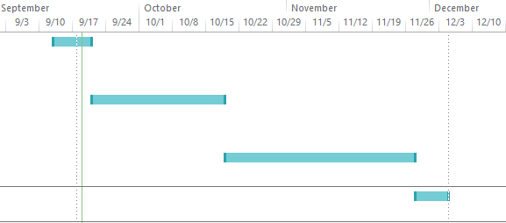

Guesstimation Data Dictionary

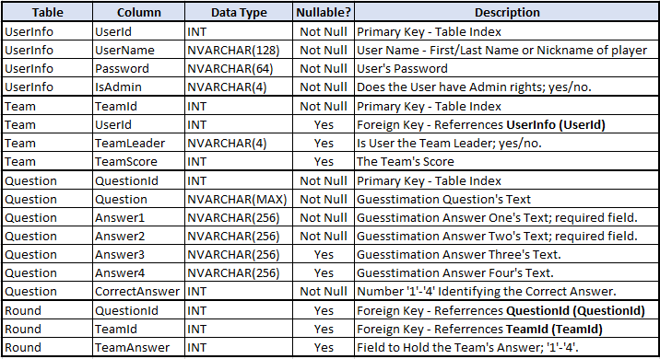

Guesstimation ERD

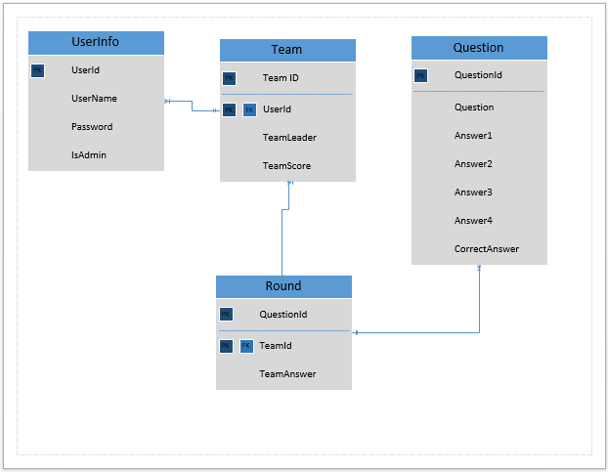

Guesstimation – Database Creation Scripts

-- Create User Table

CREATE TABLE UserInfo

(

UserId INT IDENTITY PRIMARY KEY,

UserName NVARCHAR(128) NOT NULL,

Password NVARCHAR(64) NOT NULL,

IsAdmin NVARCHAR(4) NOT NULL

)

-- Create Team Table

CREATE TABLE Team

(

TeamId INT IDENTITY PRIMARY KEY,

UserId INT REFERENCES User (UserId),

TeamLeader NVARCHAR(4),

TeamScore INT,

)

Guesstimation - Database Creation Scripts (continued)

-- Create Question Table

CREATE TABLE Question

(

QuestionId INT IDENTITY PRIMARY KEY,

Question NVARCHAR(MAX) NOT NULL,

Answer1 NVARCHAR(256) NOT NULL,

Answer2 NVARCHAR(256) NOT NULL,

Answer3 NVARCHAR(256),

Answer4 NVARCHAR(256),

CorrectAnswer INT NOT NULL

)

-- Create Round Table

CREATE TABLE Round

(

QuestionId INT REFERENCES Question (QuestionId),

TeamId INT REFERENCES Team (TeamId),

TeamAnswer INT

)

Guesstimation Data Base Connection String

Server=tcp:guesstimation.database.windows.net,1433;Initial Catalog=GuesstimationDB;Persist Security Info=False;User ID={your_username};Password={your_password};MultipleActiveResultSets=False;Encrypt=True;TrustServerCertificate=False;Connection Timeout=30;